**Load Memory Module:**

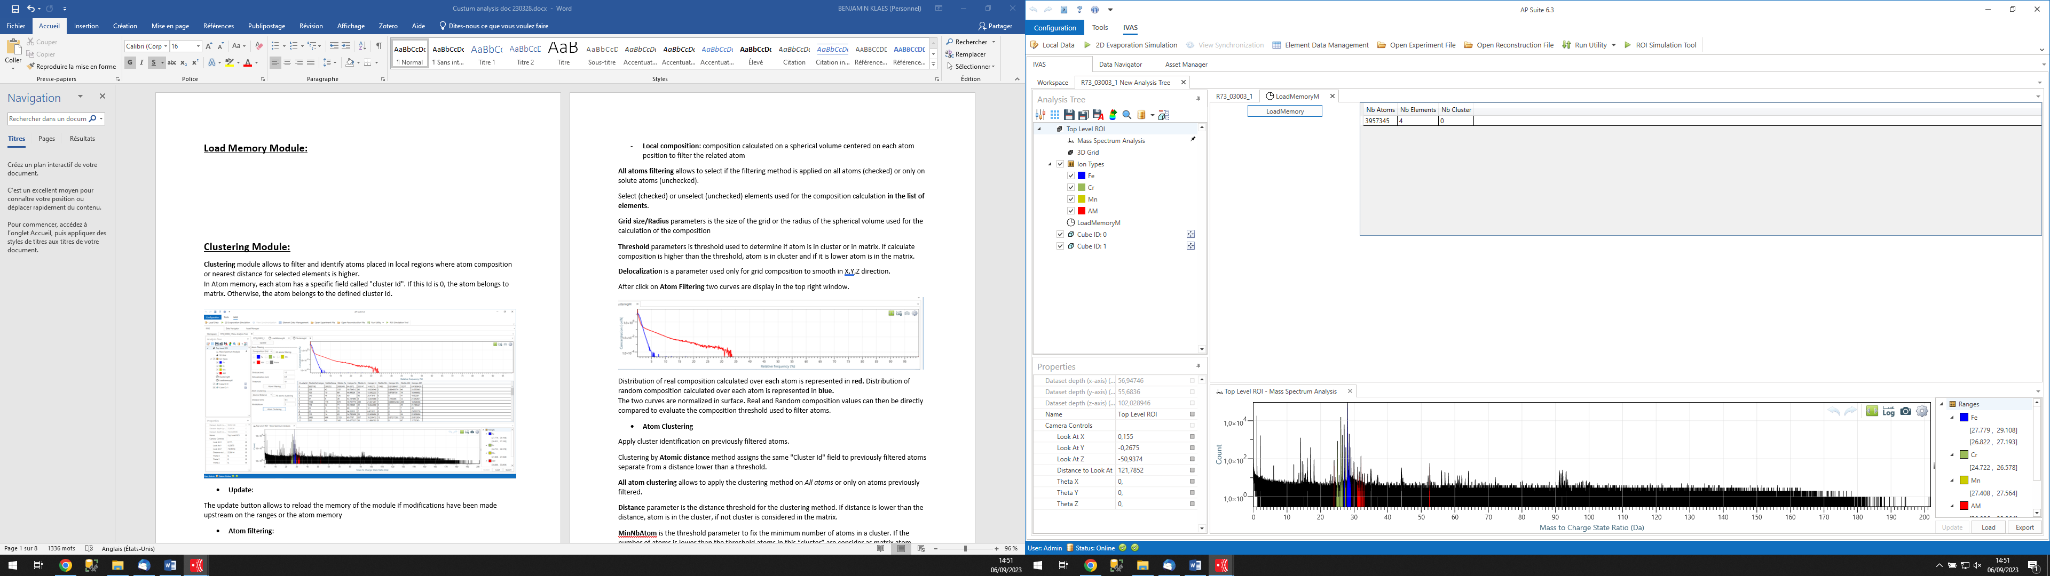

**LoadMemory** module must be used first before any other custom processing module. It allows loading the APSuite memory into a memory called CAtom that can be used by custom modules.

When the memory loading is complete, the number of atoms, the number of elements, and the number of clusters are displayed in the right-hand table.

Caution, the CAtom memory is singular. If it is reloaded after the use of other modules, anything saved in this memory during processing in the other modules will be overwritten.

**Clustering Module:**

**Clustering** moduleallows to filter and identify atoms placed in local regions where atom composition or nearest distance for selected elements is higher.  
In Atom memory, each atom has a specific field called "cluster Id". If this Id is 0, the atom belongs to matrix. Otherwise, the atom belongs to the defined cluster Id.  
  
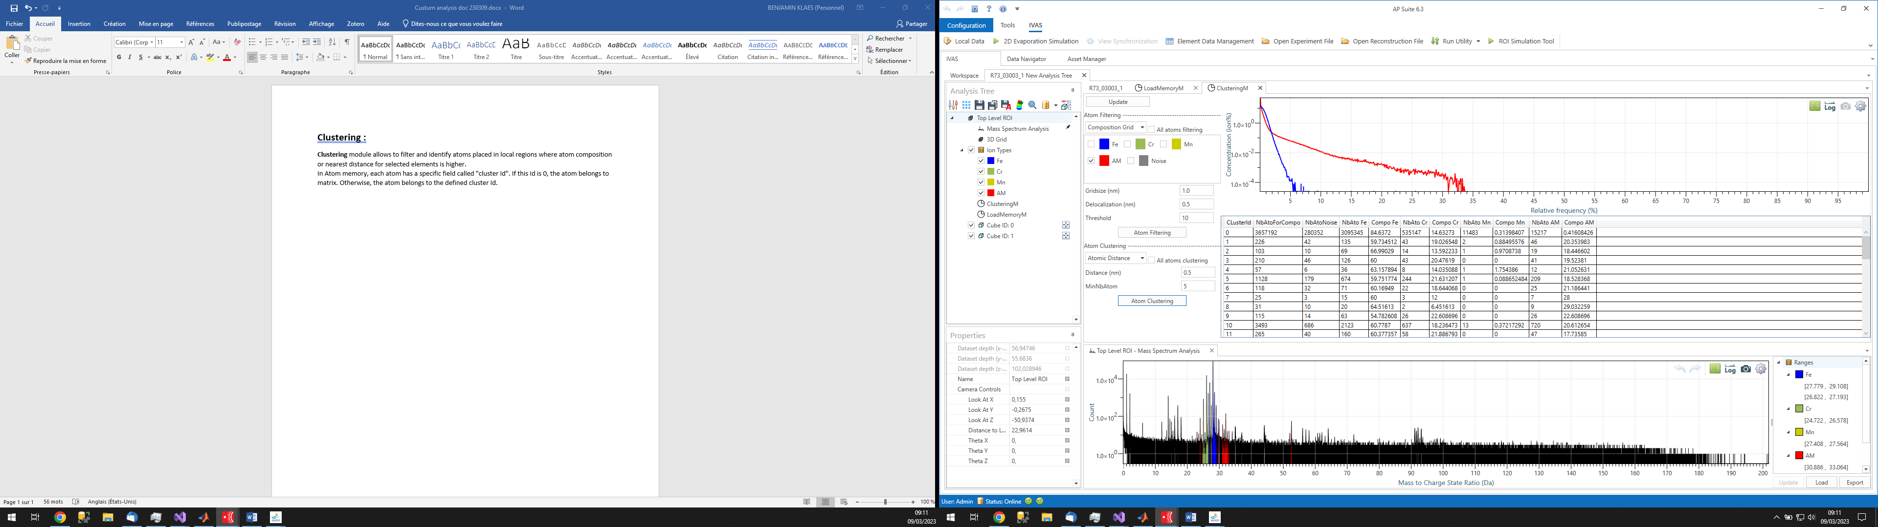

* **Update**:

The update button allows to reload the memory of the module if modifications have been made upstream on the ranges or the atom memory

* **Atom filtering**:

Filter part of atoms placed in regions where atom density, composition or nearest distance for selected elements is higher. Filtering method is based on the composition with identification of 3d regions where atomic composition for selected elements is higher.

There are two filtering options:

* **Grid composition**: use a 3D grid composition calculate on the volume to filter atom
* **Local composition**: composition calculated on a spherical volume centered on each atom position to filter the related atom

**All atoms filtering** allows to select if the filtering method is applied on all atoms (checked) or only on solute atoms (unchecked).

Select (checked) or unselect (unchecked) elements used for the composition calculation **in the list of elements**.

**Grid size/Radius** parameters is the size of the grid or the radius of the spherical volume used for the calculation of the composition

**Threshold** parameters is threshold used to determine if atom is in cluster or in matrix. If calculate composition is higher than the threshold, atom is in cluster and if it is lower atom is in the matrix.

**Delocalization** is a parameter used only for grid composition to smooth in X,Y,Z direction.

After click on **Atom Filtering** two curves are display in the top right window.

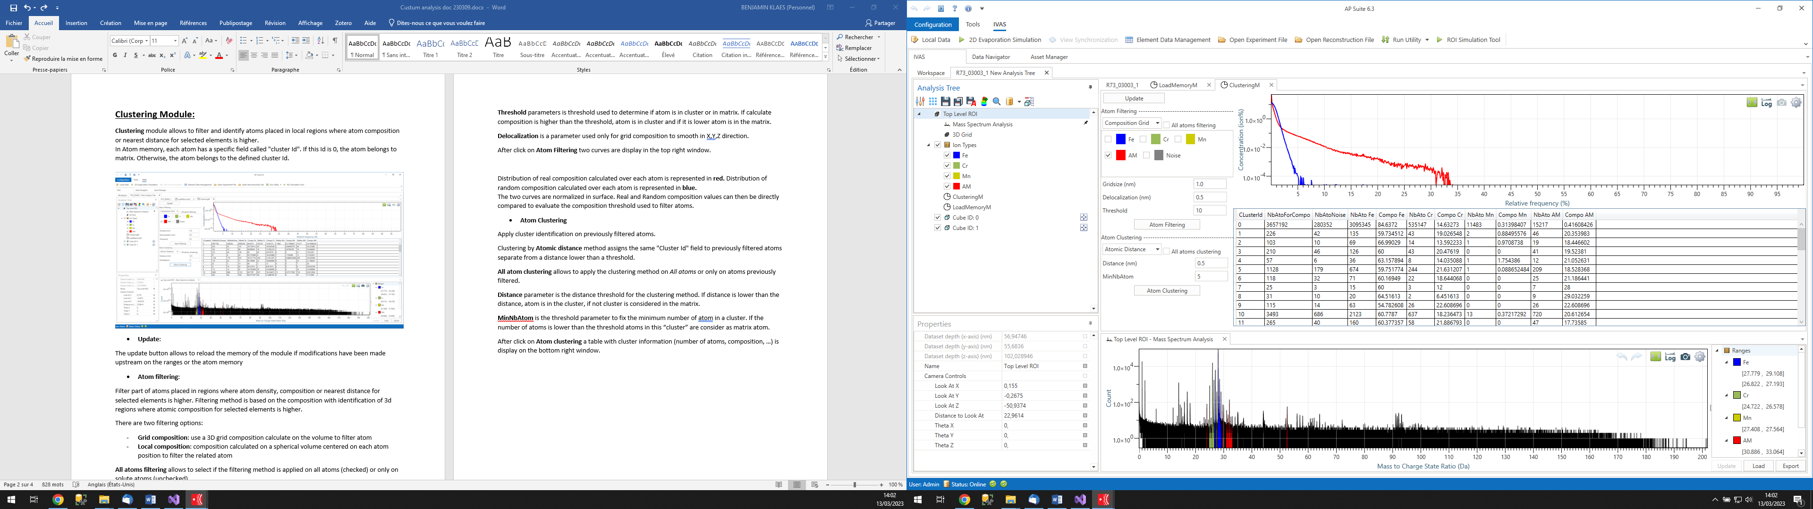

Distribution of real composition calculated over each atom is represented in **red.** Distribution of random composition calculated over each atom is represented in **blue.**  
The two curves are normalized in surface. Real and Random composition values can then be directly compared to evaluate the composition threshold used to filter atoms.

* **Atom Clustering**

Apply cluster identification on previously filtered atoms.

Clustering by **Atomic distance** method assigns the same "Cluster Id" field to previously filtered atoms separate from a distance lower than a threshold.

**All atom clustering** allows to apply the clustering method on *All atoms* or only on atoms previously filtered.

**Distance** parameter is the distance threshold for the clustering method. If distance is lower than the distance, atom is in the cluster, if not cluster is considered in the matrix.

**MinNbAtom** is the threshold parameter to fix the minimum number of atoms in a cluster. If the number of atoms is lower than the threshold atoms in this “cluster” are consider as matrix atom.

After click on **Atom clustering** a table with cluster information (number of atoms, composition, …) is display on the bottom right window.



**Cluster Position Module:**

Cluster Position module allows to represent xyz position of the current Atom memory with a color-element, color-cluster Id or color-family Id.

In Atom memory, each atom has a specific field called "cluster Id". This field comes from the result of a Clustering Module (need to be calculate before)

If this Id is 0, the atom belongs to matrix. Otherwise, the atom belongs to the specify cluster Id.

Then atom representation can be filtered in function of the cluster Id, Element Id or Family Id.

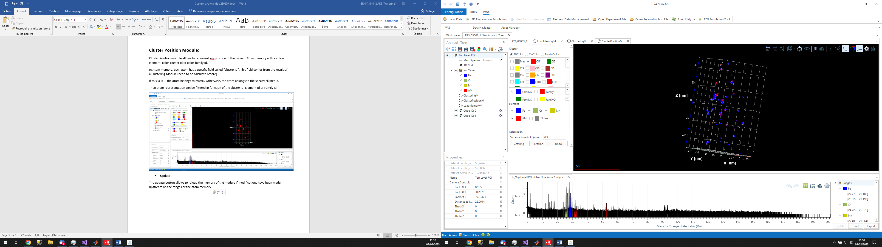

* **Update**:

The update button allows to reload the memory of the module if modifications have been made upstream on the ranges or the atom memory

* **Cluster**

Select **EltColor** to represent clusters with the color of elements, **CluColor** to represents the clusters with the color of cluster Id or **FamilyColor** to represent the clusters with the color of the family Id.

In the **list of clusters** Select (Checked) or unselect (Unchecked) the cluster to represent only selected clusters**. Right click** on this list open a contextual menu with options to **select all** the clusters, **deselect all** the clusters or **move selected cluster** to another family (only selected (checked) cluster will be move).

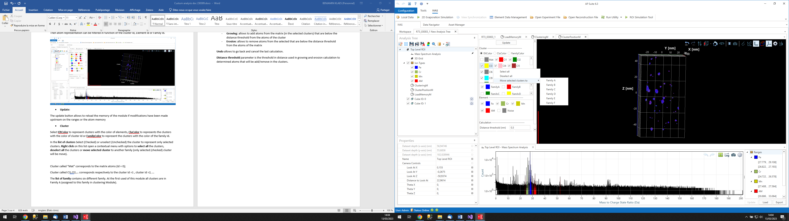

Cluster called “Mat” corresponds to the matrix atoms (Id = 0);

Cluster called Cl1,Cl2,… corresponds respectively to the cluster Id =1 , cluster Id =2, …

The **list of family** contains six different family. At the first used of this module all clusters are in Family A (assigned to this family in clustering Module).

* **Element**

The **list of elements** allows to select (checked) or unselect (unchecked) element that will be represented.

* **Calculation**

There are two calculation options:

* **Growing**: allows to add atoms from the matrix (in the selected clusters) that are below the distance threshold from the atoms of the cluster
* **Erosion**: allows to remove atoms from the selected that are below the distance threshold from the atoms of the matrix

**Undo** allows to go back and cancel the last calculation.

**Distance threshold** parameter is the threshold in distance used in growing and erosion calculation to determined atoms that will be add/remove in the clusters.

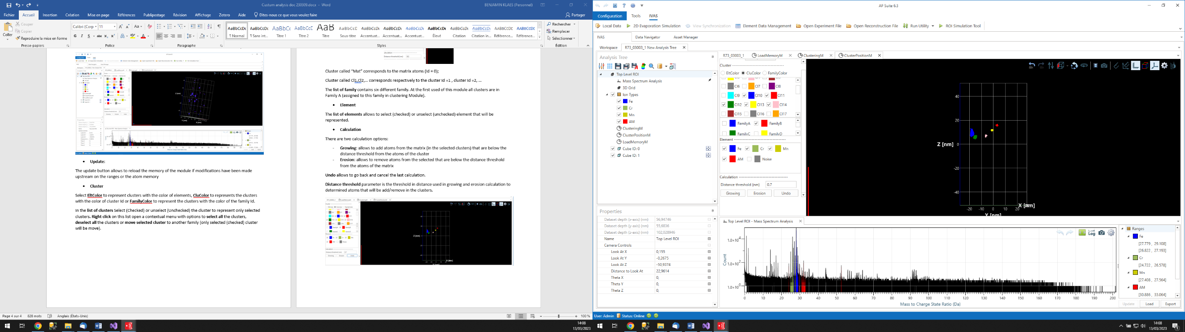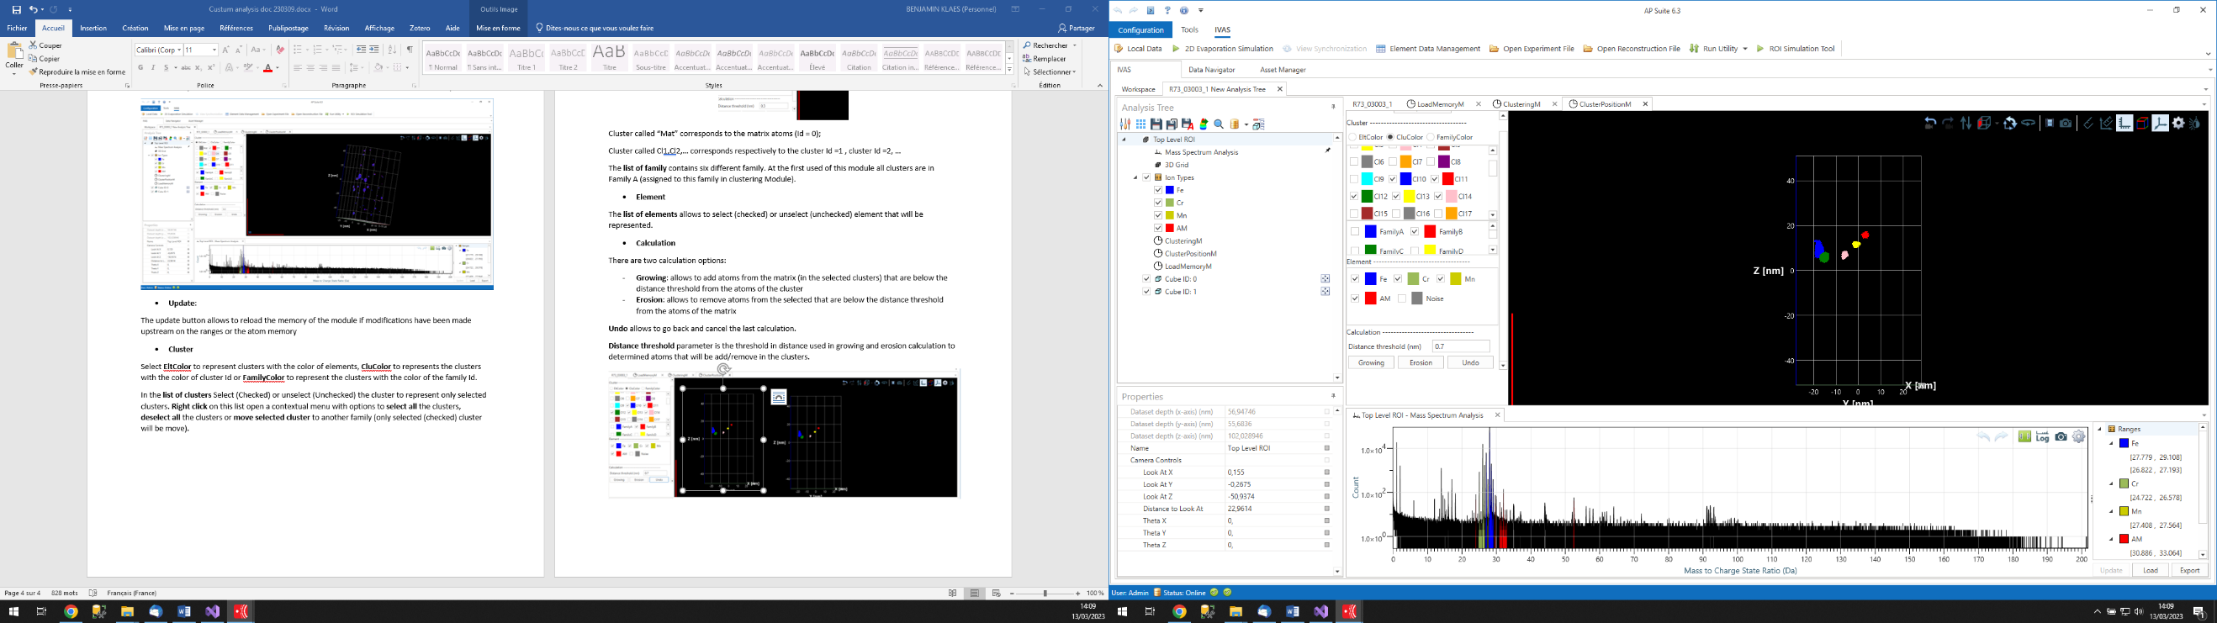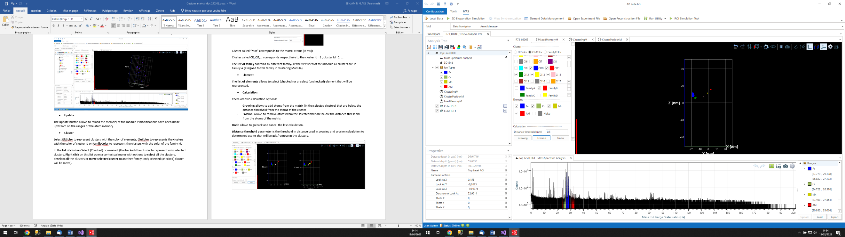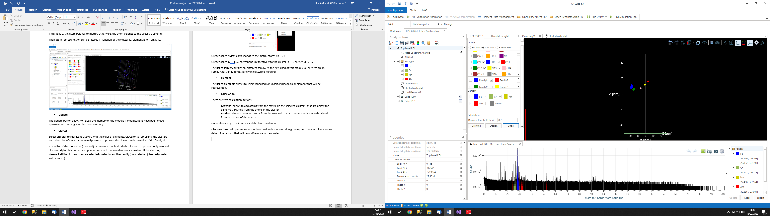

Erosion

Growing

Original

The example above shows the results for a growing and erosion calculation with a distance threshold parameter of 0.7nm. The calculation was made only on clusters in Family B.

* **K-Means clustering**

**K-means clustering** allows separating clusters that remained connected after using classical clustering methods.

First, select from the list of clusters those on which the algorithm should be applied.

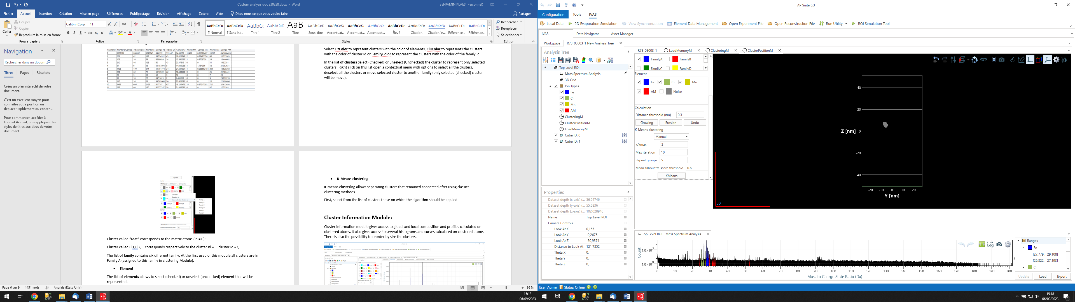

Two calculation options are possible: **Manual** or **Auto**. In **Manual** mode, you constrain the number of clusters present in the group to be separated by specifying this value in the **k/kmax** field.

In **Auto** mode, the algorithm will test all values for the number of clusters between 1 and the number indicated in the **k/kmax** field. The result for which the silhouette score is maximized will be selected by the algorithm to perform the separation of clusters in the selected group.

**Max Iteration** field is as a stopping criterion. **Max Iteratio'** is used to stop the calculation for a cluster group if the convergence of the calculation of the positions of each cluster's center within the group is not achieved before (a value less than 20 is recommended).

**Repeat groups** is the number of times the convergence calculation will be repeated for each cluster group to determine the optimal solution (a value between 3 and 6 is recommended).

The **Mean Silhouette Score Threshold** field allows filtering the cluster groups affected by the calculation. If, for a group, the score is below the specified threshold, then the cluster separation will not occur. This helps filter out, especially in automatic mode, cluster groups where separation is not possible or not reliable. This value depends on the shape and configuration of the cluster group, but generally, a calculation resulting in a mean silhouette score lower than 0.55 can be excluded.

**Cluster Information Module:**

Cluster information module gives access to global and local composition and profiles calculated on clustered atoms. It also gives access to several histograms and curves calculated on clustered atoms. There is also the possibility to reorder by size the clusters.

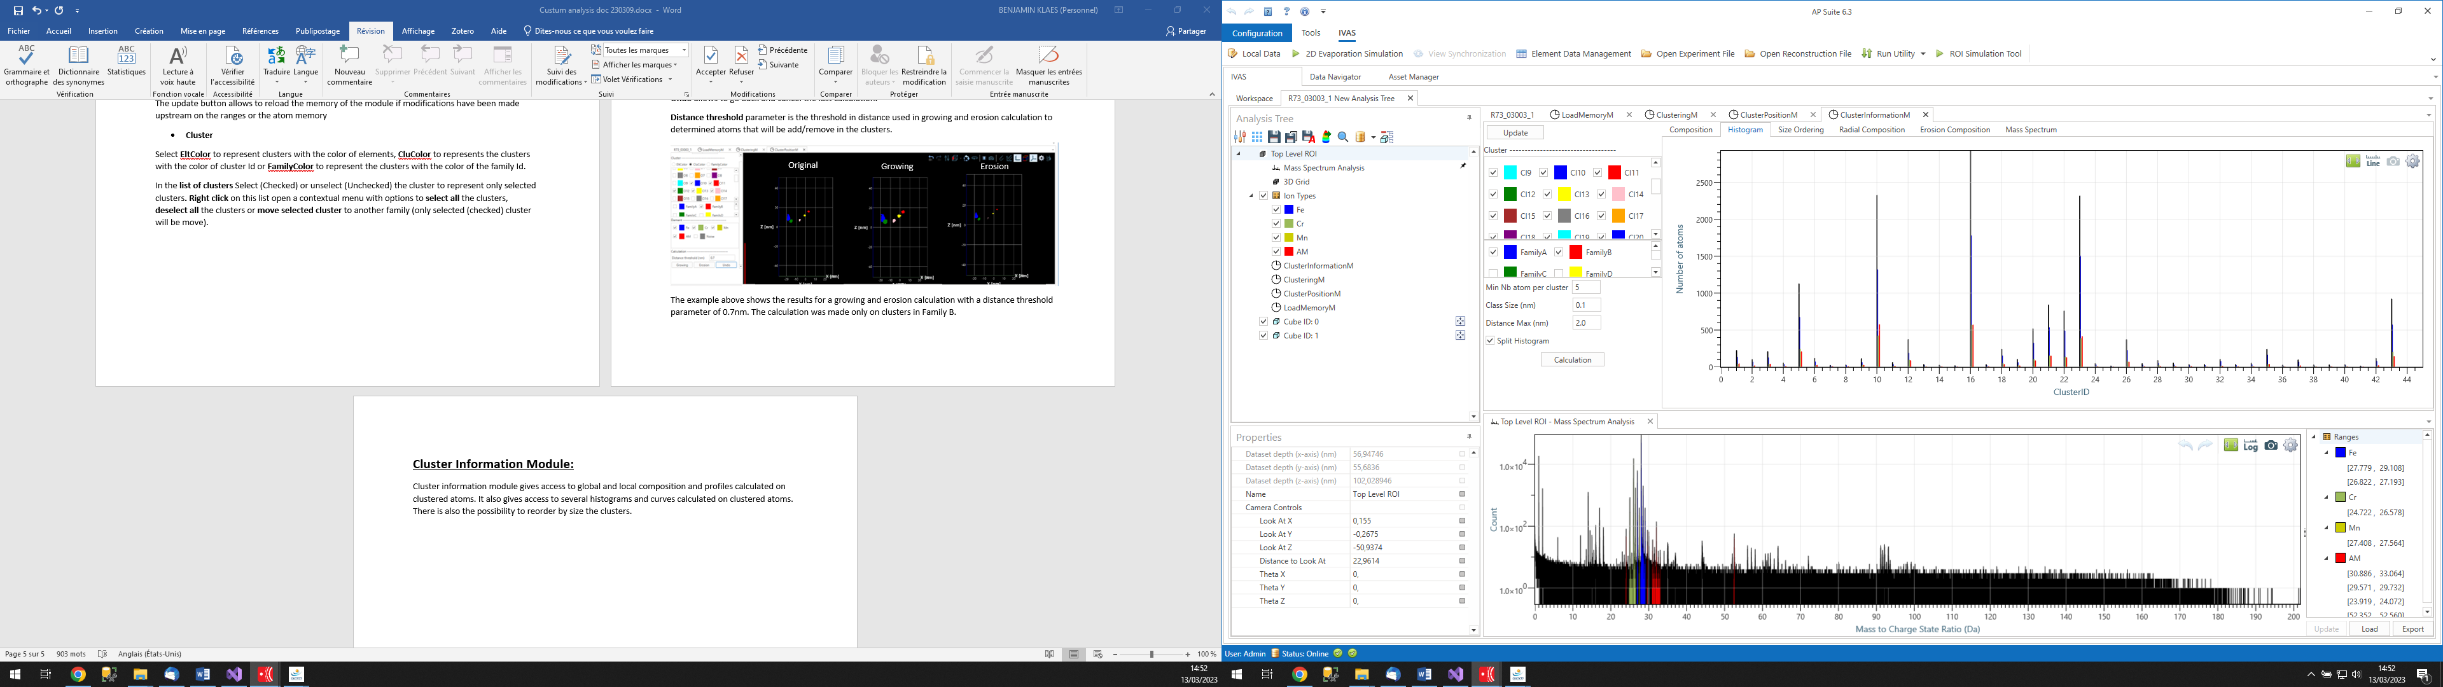

The calculation is made on the selected tab :

* **Composition**

**Composition** tab shows a table with the composition of each selected cluster.

For each selected cluster and from atoms in memory, this application calculates the number of atoms, the composition and the relative error associated to elements defined in the Environment file.  
The equivalent Guinier - Giration radius, the average position an are also available.  
Note that composition weight parameter, defined for each mass range, is used to calculate composition value.

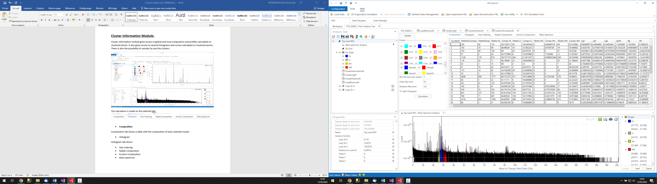

* **Histogram**

**Histogram** tab shows a histogram of the composition per selected clusters. For each selected cluster and from atoms in memory the number of atoms in mass is plot on the histogram.

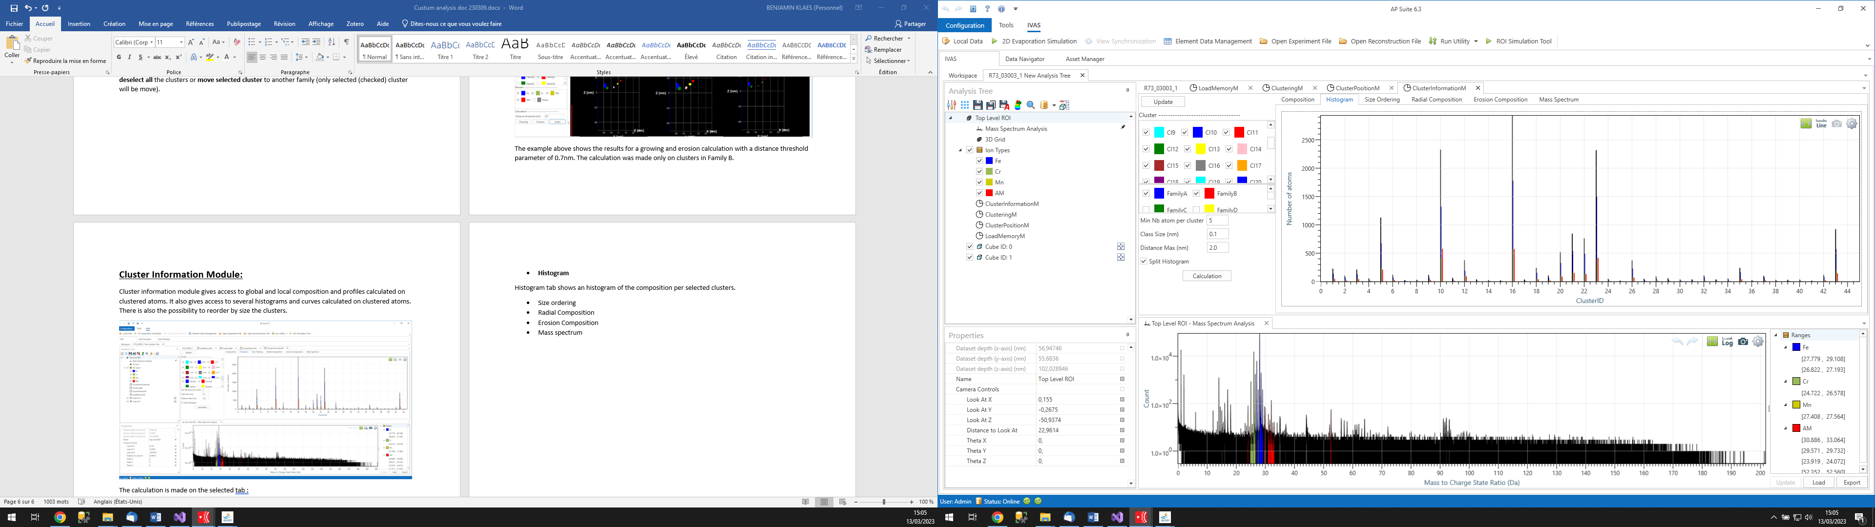

* **Size ordering**

The **size ordering** tab will reorder the clusters from the one with the fewest atoms to the one with the most.

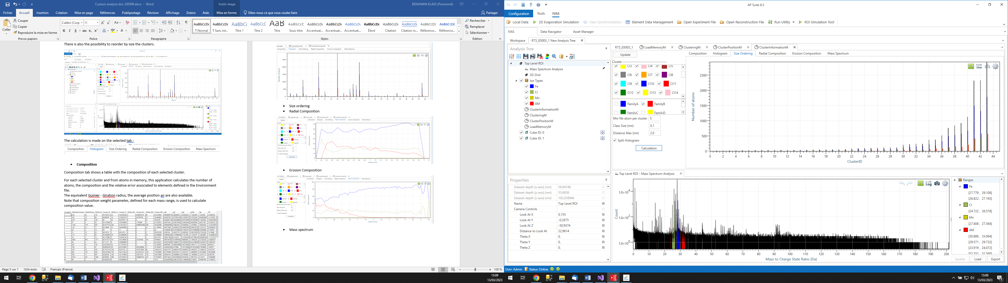

* **Radial Composition**

For each selected cluster and from atoms available in memory, this application places a spherical volume to the average of the related atom positions.  
The radius of this volume increases step by step until a maximum value, that allows to calculate and show the variation of element composition inside each step.  
If more than one cluster is selected, the profile is the result of the sum of variations calculated over each individual cluster.

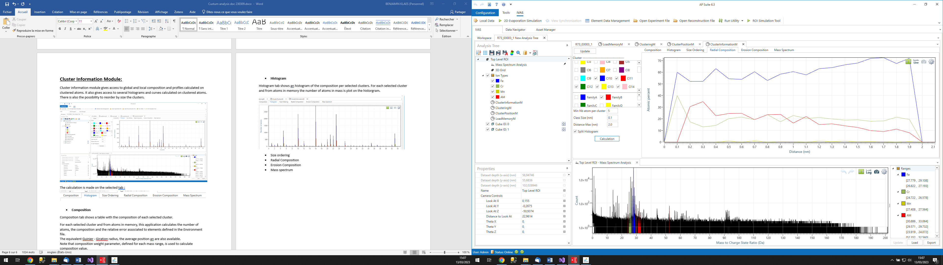

**Class size** parameter defines the increment value of the sphere radius.  
**Distance Max** parameter defines the maximum radius variation used to build the profile.

* **Erosion Composition**

For each selected cluster and from atoms available in memory, this application places a 3d shape volume corresponding to the cluster - matrix interface.  
The distance from both side of this interface shape increases step by step, that allows to calculate and shows the variation of element composition inside each step from matrix to cluster and from cluster to matrix interfaces.  
If more than one cluster is selected, the profile is the result of the sum of variations calculated over each individual cluster.

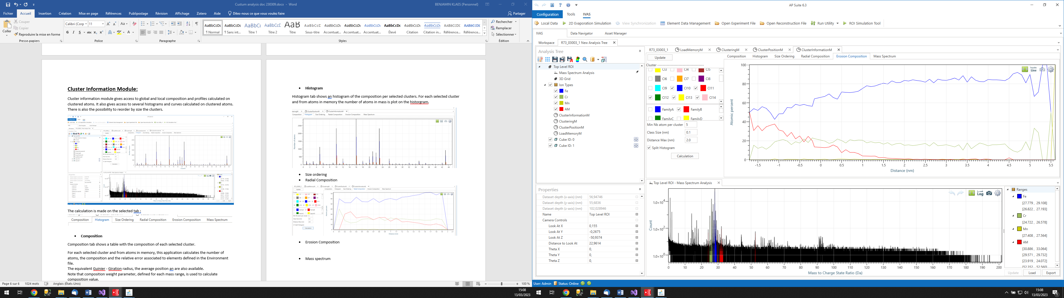

**Class size** parameter defines the increment value of the distances between atoms and the 3d shape volume corresponding to the cluster - matrix interface.  
**Distance Max** parameter defines the maximum distance used for atoms from matrix that surround the 3d shape volume corresponding to the cluster - matrix interface.

* **Mass spectrum**

The **mass spectrum** tab shows the histogram for each selected cluster. If **split histogram** is checked, one mass spectrum will display for each selected cluster with the color of the corresponding cluster. If **split histogram** is unchecked, only one mass spectrum will be display. This mass spectrum is the sum of all the mass spectrum of each selected clusters.

